**INPUT**

<html>

<head><title>Database programs</title></head>

<body>

<center>

<form method='post'>

<h1>Student database aggregate functions</h1><br>

<b>Choose any of the following options from dropdown list</b><br><br>

<select name="ddl1">

<option name="Sum Of Marks">Sum Of Marks</option>

<option name="Average Of Marks">Average Of Marks</option>

<option name="Count Of Marks">Count Of Marks</option>

<option name="Maximum Marks">Maximum Marks</option>

<option name="Minimum Marks">Minimum Marks</option>

<option name="COUNT(DISTINCT)">Distinct Count Of Marks</option>

</select>

<input type="submit" name="submit">

</form>

<?php

$con=mysqli_connect("localhost","root","") or die(mysqli_error());

$db=mysqli_select_db($con,'student');

if (isset($_POST['submit'])) {

$ddl2=$_POST['ddl1'];

if ($ddl2=='Sum Of Marks') {

$st="SELECT SUM(Marks) FROM student_table";

$res=mysqli_query($con,$st);

$value=mysqli_fetch_array($res);

echo "Sum of marks is "."<b>".$value[0]."</b>";

}

if ($ddl2=='Average Of Marks') {

$st="SELECT AVG(Marks) FROM student_table";

$res=mysqli_query($con,$st);

$value=mysqli_fetch_array($res);

echo "Average of marks is "."<b>".$value[0]."</b>";

}

if ($ddl2=='Count Of Marks') {

$st="SELECT COUNT(Marks) FROM student_table";

$res=mysqli_query($con,$st);

$value=mysqli_fetch_array($res);

echo "Count of marks is "."<b>".$value[0]."</b>";

}

if ($ddl2=="Maximum Marks") {

$st="SELECT MAX(Marks) FROM student_table";

$res=mysqli_query($con,$st);

$value=mysqli_fetch_array($res);

echo "Maximum mark is "."<b>".$value[0]."</b>";

}

if ($ddl2=="Minimum Marks") {

$st="SELECT MIN(Marks) FROM student_table";

$res=mysqli_query($con,$st);

$value=mysqli_fetch_array($res);

echo "Minimum mark is "."<b>".$value[0]."</b>";

}

if ($ddl2=="Distinct Count Of Marks") {

$st="SELECT COUNT(DISTINCT Marks) FROM student_table";

$res=mysqli_query($con,$st);

$value=mysqli_fetch_array($res);

echo "Count of distinct marks is "."<b>".$value[0]."</b>";

}

}

?>

</center>

</body>

</html>

**OUTPUT**











**INPUT**

<html>

<head>

<title>SQL insert program</title>

</head>

<body>

<center>

<h1>SQL Insert Operation</h1>

<form method="post">

Enter your first name : <input type="text" name="fname"><br><br>

Enter your last name : <input type="text" name="lname"><br><br>

Enter your class [FY/SY/TY] : <input type="text" name="class"><br><br>

Enter your age : <input type="text" name="age"><br><br>

Enter your marks : <input type="text" name="marks"><br><br>

<input type="submit" name="submit"><br>

</form>

</center>

</body>

</html>

<?php

$con=mysqli_connect("localhost","root","") or die(mysqli_error());

$db=mysqli_select_db($con,'student');

if(isset($_POST['submit']))

{

$fname=$_POST['fname'];

$lname=$_POST['lname'];

$class=$_POST['class'];

$age=$_POST['age'];

$marks=$_POST['marks'];

$st="INSERT INTO student(Fname,Lname,Class,Age,Marks) VALUES ('$fname','$lname','$class','$age','$marks')";

$res=mysqli_query($con,$st);

if($res)

{

echo "<center>Below Data Added Successfully</center><br>";

echo "<center>First name is <b>".$fname."</b></center>";

echo "<center>Last name is <b>".$lname."</b></center>";

echo "<center>Class is <b>".$class."</b></center>";

echo "<center>Age is <b>".$age."</b></center>";

echo "<center>Marks is <b>".$marks."</b></center>";

}

else

{echo "<center>There is a problem while inserting Data in database</center>";}

}

?>

**OUTPUT**

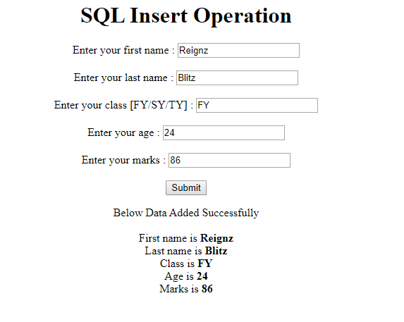

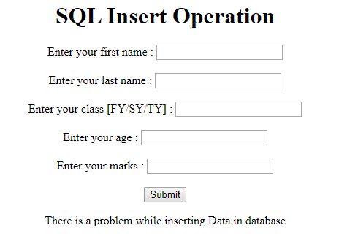

**INPUT**

<html>

<head>

<title>SQL insert program</title>

</head> <body> <center>

<form method="post">

<h1><font color="green">REGISTRATION FORM</font></h1>

Enter your first name : <input type="text" name="fname"><br><br>

Enter your last name : <input type="text" name="lname"><br><br>

Enter your address : <input type="textarea" name="ta"><br><br>

Enter your age : <input type="text" name="age"><br><br>

Enter your email-id : <input type="text" name="eid"><br><br>

<input type="submit" name="submit"><br><br>

</form> </center> </body>

</html>

<?php

$con=mysqli_connect("localhost","root","") or die(mysqli_error());

$db=mysqli_select_db($con,'student');

$fname1=$lname1=$add=$age=$id=" ";

if(isset($_POST['submit']))

{

if(empty($_POST['fname']))

{

echo "<center><b>First name is mandatory!!!</b></center>";

}

if(empty($_POST['lname']))

{

echo "<center><b>Last name is mandatory!!!</b></center>";

}

if(empty($_POST['ta']))

{

echo "<center><b>Address is mandatory!!!</b></center>";

}

if(empty($_POST['age']))

{

echo "<center><b>Age is mandatory!!!</b></center>";

}

if(empty($_POST['eid']))

{

echo "<center><b>Email id is mandatory!!!</b></center>";

}

if(!filter_var($_POST['eid'],FILTER_VALIDATE_EMAIL))

{

echo "<center><b>Invalid mail format</b></center>";

}

$fname1=$_POST['fname'];

$lname1=$_POST['lname'];

$add=$_POST['ta'];

$age=$_POST['age'];

$id=$_POST['eid'];

$st="INSERT INTO registration(Fname,Lname,Address,Age,EmailId) VALUES ('$fname1','$lname1','$add','$age','$id')";

$res=mysqli_query($con,$st);

if(($con->query($st)==TRUE) && (!empty($_POST['fname'])) && (!empty($_POST['lname'])) && (!empty($_POST['ta'])) && (!empty($_POST['age'])) && (!empty($_POST['eid'])) && (filter_var($_POST['eid'],FILTER_VALIDATE_EMAIL)))

{

echo "<center><b>You Registered Successfully</b></center>";

}

else

{

echo "<center><b>There is a problem while inserting data in database<br>".$con->error."</b></center>";

}

}

?>

**OUTPUT**



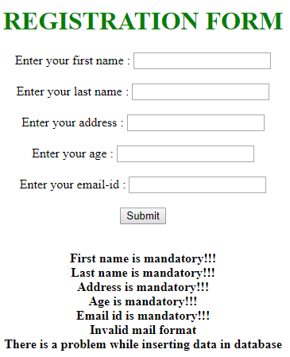

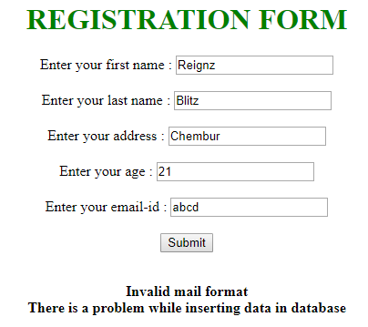 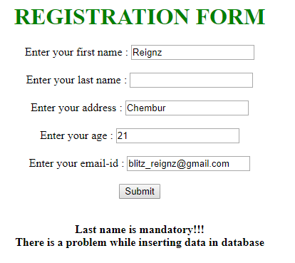



**INPUT**

<html><head>

<title>SQL insert program</title>

</head> <body>

<center> <form method="post">

<h1><font color="green">LOGIN FORM</font></h1>

Enter your username : <input type="text" name="fname"><br><br>

Enter your password : <input type="text" name="lname"><br><br>

<input type="submit" name="submit" value="Login"><br>

</form> </center>

</body> </html>

<?php

$con=mysqli_connect("localhost","root","") or die(mysqli_error());

$db=mysqli_select_db($con,'student');

$fname1=$lname1=$add=$age=$id=" ";

if(isset($_POST['submit'])) {

$fname1=$_POST['fname'];

$pass=$_POST['lname'];

$st="SELECT Fname,password FROM login WHERE Fname='$fname1' AND password='$pass' ";

$res=mysqli_query($con,$st);

$row=mysqli_fetch_assoc($res);

if($row["Fname"]==$fname1 && $row["password"]==$pass && (!empty($_POST['fname'])) && (!empty($_POST['fname'])))

{

echo "<center><b>Login Successful</b></center>";

}

else

{

echo "<center><b>There is a problem while login<br>".$st."<br>".$con->error."</b></center>";

}

}

?>

**OUTPUT**





